SIKA PLASTIX-22A (Premium Grade)

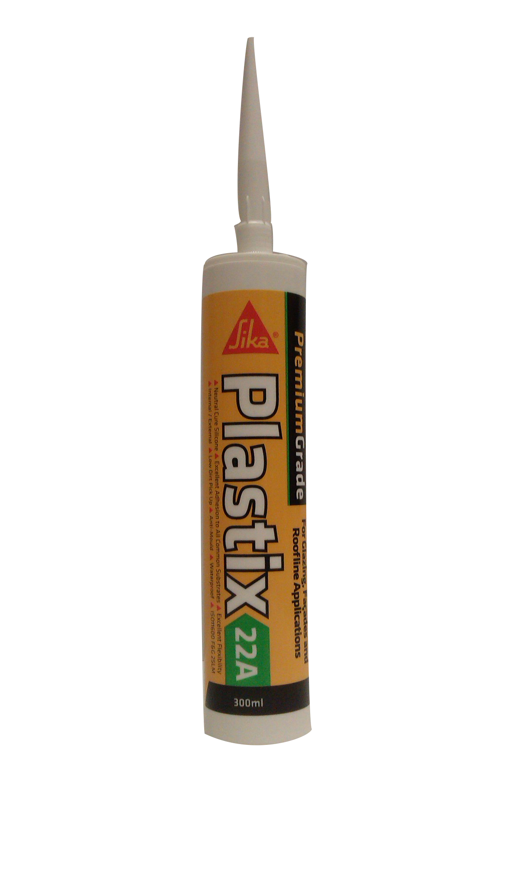
Colour | Product Code | Pack Size | Box Qty
Anthracite | SKPLAS22AANTH | 300ml | 12
Black | SKPLAS22ABK | 300ml | 12
Chartwell Green | SKPLAS22ACHGN | 300ml | 12
Teak | SKPLAS22ATK | 300ml | 12
Caramel | SKPLAS22ACML | 300ml | 12
Translucent | SKPLAS22ATR | 300ml | 12
Brilliant White | SKPLAS22AWE | 300ml | 12
Product Description
Sika® PLASTIX-22A is a premium grade low modulus, neutral curing silicone sealant suitable for many construction and industrial applications but particularly suited for all glazing, façade and roofline applications. Certified to: EN15651-1 type F EXT-INT-CC, Class 25LM, EN15651-2 type G-CC, Class G25LM, EN15651-3 type S, Class XS1

Benefits
- Excellent primerless adhesion to all common building substrates, porous and non-porous.
- Internal and External use.
- Fast curing.
- Solvent free.
- Virtually odourless.
- Low dirt pick up.
- Excellent break off and tooling.
- Excellent flexibility +/- 25%.
- Waterproof.
- Weather resistant.
- UV resistant.
- Chemical resistant.
- Service temperature resistance (-50ºC to +150ºC)
- Suitable for use with glass, lead, polycarbonate, and acrylic sheets.
- Certified for façade, glazing, cold climate and sanitary applications under EN15651.

Areas for Use
- Perimeter pointing around uPVC, wood, aluminium and all other types of window and door frames.
- Expansion joint sealing.
- Weather sealing and joint sealing of aluminium glazing systems, curtain walling and pre-formed façade panels.
- General glazing sealing and draught proofing including repair work over existing sealant.
- Parapet and roofline weather sealing.
- Sanitary sealing.
- Glass to glass and glass to aluminium sealing.
- Sealing soft metals such as lead, brass, copper and zinc.
- Industrial sealing applications, coated metals, anodized aluminium and stainless steel.
- General maintenance sealing of cars, caravans, mobile homes and boats.

Limitations
- Do not use in conjunction with bitumen or asphalt.
- Do not use in the manufacture of Aquariums.
- Do not use on substrates that bleed oil, solvents or plasticisers.
- Non Overpaintable.

Surface Preparation
The surfaces to be must be clean, dry and free from dust, grease and other contaminants.
Improve adhesion by wiping surface with a suitable proprietary cleaner. Priming is generally not required, although we always advise testing small areas prior to use.

Application
All glazing must be carried out according to current relevant British standard. Apply at temperatures between +5ºC and +35ºC o clean dry surfaces. The joint depth must never be greater than 50% of the width.

Cut the tip of the cartridge taking care not to damage the thread. Apply nozzle and cut at an angle of 45º with an opening slightly larger than the gap to be sealed. Apply using a standard sealant gun. Best results will be obtained by keeping an even pressure on the trigger and keeping the gun at a constant angle to the surface being sealed. To ensure a proper bond, always smooth the sealant down with a spatula or piece of wood. An improved joint appearance can be achieved by placing masking tape to both sides of the joint, removing within 15 minutes of application.

Specific Data

TEST | RESULT
Movement accommodation | + or -25%
Skinning time: | 5 - 25 mins
Cure time | 1-2mm per 24 hours
Hardness Shore A | 20
Service temperature resistance | -50°C to + 150°C
Application temperature resistance | +5°C to + 35°C
Specific gravity | 1.02 g/cm³
Cleaning | Uncured sealant white spirit.
Minimum joint width | 5mm
Maximum joint width | 50mm
Joint ratio | Maximum depth, 50% of joint width
Coverage | 10.5 linear meters as a 6mm diameter bead

Health & Safety
Consult MSDS for full list of hazards.

Storage
Store in cool dry conditions away from direct sunlight between 5ºC and 30ºC. Storage outside these parameters will dramatically reduce the shelf life.

Shelf Life
Use 18 months from date of manufacture.

The technical data contained herein is based on our present knowledge and experience and we cannot be held liable for any errors, inaccuracies, omissions or editorial failings that result from technological changes or research between the date of issue of this document and the date the product is acquired. Before using the product, the user should carry out any necessary tests in order to ensure that the product is suitable for the intended application. Moreover, all users should contact the seller or the manufacturer of the product for additional technical information concerning its use if they think that the information in their possession needs to be clarified in any way, whether for normal use or a specific application of our product. Our guarantee applies within the context of the statutory regulations and provisions in force, current professional standards and in accordance

with the stipulations set out in our general sales conditions. The information detailed in the present technical data sheet is given by way of indication and is not exhaustive. The same applies to any information provided verbally by telephone to any prospective or existing customer.

