CLEAR FIX

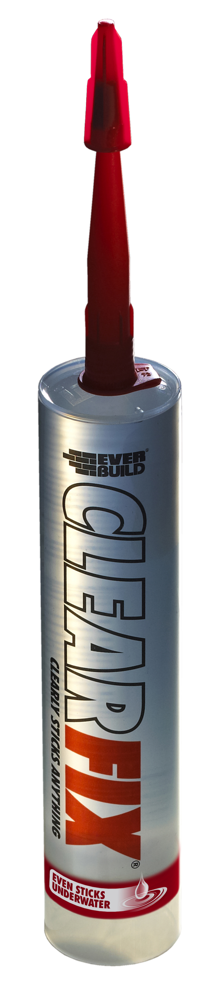
Colour | Product Code | Pack Size | Box Qty
Crystal Clear | CLEARFIX3 | 290ml | 12

Product Description
CLEAR FIX is a one part, chemically curing solvent free adhesive combining the best qualities of silicone and polyurethane technologies. It is specifically designed for adhering most common building surfaces to each other and themselves.

Benefits
- Incredible initial grab, no slip and gap filling properties.
- High bonding strength
- Interior and Exterior Use
- Can be applied to Wet Surfaces
- Totally Waterproof & Weatherproof
- Quick Curing.
- Overpaintable if required
- Solvent Free
- Resistant to temperature extremes -40°C to +150°C
- Resistant to Chemicals & Petrol (10% dilute acids/alkalis, most solvents)
- Excellent primer less adhesion to most surfaces, including metals, most plastics, glass, concrete, plaster, plasterboard, polyester, Perspex, glass, wood, enamel, painted surfaces etc etc.

Areas For Use
- Bonding in almost every application imaginable. The following are just some examples.
- As a high quality nail replacement adhesive, even to damp surfaces.
- External and internal perimeter pointing around doors and windows, especially in mobile structures such as caravans and boats.
- Bonding mirrors to most common substrates.
- Automotive gap filling and sealing.
- Jointing cladding panels.
- Bonding difficult materials such as specialised polymer systems, metals and fibreglass
- Any application requiring high performance, durable sealing and bonding of joints.
- Applications where resistance to chemical spillage is required (garage forecourts etc)

Limitations
- Use on overhead applications – Always use in conjunction with mechanical fixings.
- Use in conjunction with mechanical fixings for glass block fitting or large mirrors (>0.5m2 total area)
- For heavy items, provide temporary support until adhesive has dried.
- In areas of high temperature / UV; some darkening/discolouration may occur. This does not affect the performance of the sealant
- Do not seal mirror edges/plastic sheeting until adhesive has cured.
- Overpaintability: check compatibility with specific paint first before over painting large areas.
- Do not use on surfaces that bleed oils or plasticizers
- It is the user’s responsibility to determine suitability for use. If in doubt, please contact Technical Services Department for advice.
- Not for use as part of a structural glazing system.
- Not for use in aquarium manufacture. Use AQUA MATE
- Not for use in conjunction with bitumen, or asphalt. Use WEATHER MATE
- Do not use in conjunction with undiluted bleach, this can cause can discoloration of product.
- Not suitable for use in or around chlorinated water
- Yellowing can occur in the dark

Surface Preparation
All surfaces must be clean and dust free. Surfaces may be damp, but have no standing water.

Application
Cut the tip of the cartridge taking care not to damage the thread. Fix nozzle, cut aperture to required width and apply with a standard sealant gun.

As a nail replacement (panel) adhesive.
- Surfaces must be sound, clean, dry and free from dust, grease, loose material etc.
- Prime dusty surfaces with EVERBUILD PVA BOND diluted 1:4 with water and allow to dry.
- Apply using a standard sealant gun, cut tip of cartridge, apply nozzle and cut an opening to suite the required bead size.
- For bonding heavy items (Plasterboard/worktops/wall panels etc) apply adhesive all the way around the edge of the item (30-50mm from edge) and cover back with beads of adhesive at 300mm intervals. Alternatively, apply adhesive direct to battens and press into place. NOTE.
- With heavy items, always provide temporary support until the adhesive dries.
- For bonding lightweight items (covings, dado rails, skirting etc) apply adhesive to back of item in one or two continuous beads and press immediately into place.
- Where gap filling is required, mark the areas where there is a large gap and apply a thicker bead to these areas.
- In all cases, clean up excess adhesive immediately with a cloth/white spirits.

Fixing mirrors
Apply 6mm diameter beads of sealant direct to back of mirror in vertical strips, spaced at 30-40mm centers. Immediately place mirror in position and secure with good, even pressure with a slight twist action. Provide temporary support (tape) until adhesive has dried (24-48 hours). If required, CLEAR FIX may also be used to seal around mirror 24 hours after fixing (to allow for cure)

Uncured material can be removed by wiping with a dampened cloth with white spirit. Cured material can be carefully removed by mechanical means. Full cure must be allowed before over painting.

Specific Data
Skinning Time | 15-30 mins
Cure Time | 2-3mm per 24 hours in depth
Hardness Shore A | 40-50
Elongation @ Break | >100% (ISO8339)
Application Temperature | +5 to +40°C
Service Temperature | -40 to +150°C
Staining Of Substrate | Nil
Resistance To Slump | Excellent
Overpaintability | Overpaintable with some acrylic paints – care with alkyds
Specific Gravity | 1.02-1.05
Cleaning | Uncured product: white spirits  Cured product: silicone eater
Max Joint Width | 25mm
Min Joint Width (in sealing applications as a movement joint) | 5mm
Coverage | Approximately 11 linear meters per cartridge

Health & Safety
Consult MSDS for full list of hazards.

Storage
Store in cool dry conditions between + 5°C and 25°C.

Shelf Life
Cartridge - 12 months in original unopened containers.

The technical data contained herein is based on our present knowledge and experience and we cannot be held liable for any errors, inaccuracies, omissions or editorial failings that result from technological changes or research between the date of issue of this document and the date the product is acquired. Before using the product, the user should carry out any necessary tests in order to ensure that the product is suitable for the intended application. Moreover, all users should contact the seller or the manufacturer of the product for additional technical information concerning its use if they think that the information in their possession needs to be clarified in any way, whether for normal use or a specific application of our product. Our guarantee applies within the context of the statutory regulations and provisions in force, current professional standards and in accordance with the stipulations set out in our general sales conditions. The information detailed in the present technical data sheet is given by way of indication and is not exhaustive. The same applies to any information provided verbally by telephone to any prospective or existing customer.

