AFTER TILE MOULD REMOVER SPRAY

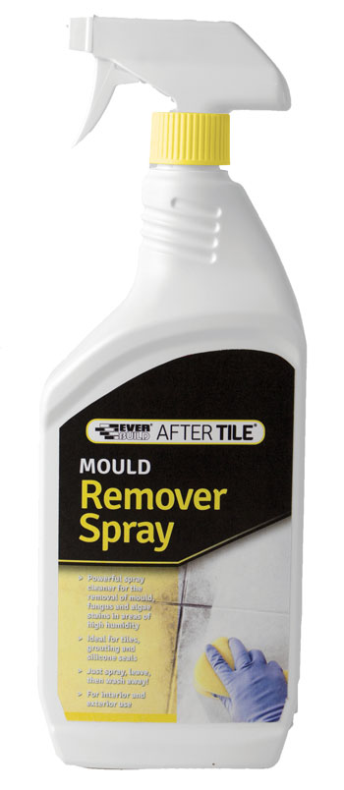

Colour | Product Code | Pack Size | Box Qty
Clear | ATMOULD1 | 1LTR | 12

Product Description
Mould Remover Spray is a ready to use sprayable solution for the removal of mould, fungus and algae and their associated stains from bathrooms, kitchens and other areas of high humidity. These black stains are mainly found around the tile grout, silicone seals and at the edges of tiles, this easy to use spray is the ideal way to remove these stains with minimal effort. Just spray, leave and wash away – there is no scrubbing required.

Suitable for use internally and externally on glazed tiles, grout, sanitary ware, shower areas, pools, saunas, kitchen surfaces etc.

Benefits
- Powerful spray cleaner for the removal of mould, fungus and algae stains in areas of high humidity.
- Ideal for tiles, grouting and silicone seals
- Just spray, leave and then wash away!
- For interior and exterior use

Areas For Use
- Bathrooms
- Shower areas
- Pools
- Kitchen areas

Limitations
- Always follow manufacturer’s instructions carefully.
- Ventilate areas well during use.
- Always test a small inconspicuous area prior to full application.
- Do not use on soft metals such as copper, brass, anodised aluminium and decorative trims.
- Do not use on wood.
- Avoid splashes on paints, coloured surfaces and fabrics.
- As the company cannot be aware of all applications and materials its product may be used on, it is the user’s responsibility to determine suitability for use. Please contact Technical Services for advice or request Technical Data Sheet.

Application
Read all instructions carefully before use
Product contains bleach. ALWAYS test a small inconspicuous area prior to full application.
Use in a well ventilated area and wear suitable rubber/latex gloves.
Press down on the button on the top of the spray head and turn the nozzle ¼ turn anticlockwise.
Squeeze trigger and spray 5-10cm away from surface to be treated.
Leave for 30 minutes then remove with a sponge and clean fresh water.
Repeat above procedure for heavily soiled areas. Always wash down after use.

Specific Data
Appearance | Clear/Pale green liquid
Application Temp | 5ºC to 35ºC
% Available Chlorine | 1.5 – 2.0
Coverage | Approx. 10m2 per litre depending on substrate

Health & Safety
Consult MSDS for full list of hazards.

Storage
Store in cool, dry conditions between + 5 and + 25˚C. PROTECT FROM FROST. Storage outside these parameters will dramatically reduce shelf life.

Shelf Life
12 months from date of manufacture in original unopened containers.

The technical data contained herein is based on our present knowledge and experience and we cannot be held liable for any errors, inaccuracies, omissions or editorial failings that result from technological changes or research between the date of issue of this document and the date the product is acquired. Before using the product, the user should carry out any necessary tests in order to ensure that the product is suitable for the intended application. Moreover, all users should contact the seller or the manufacturer of the product for additional technical information concerning its use if they think that the information in their possession needs to be clarified in any way, whether for normal use or a specific application of our product. Our guarantee applies within the context of the statutory regulations and provisions in force, current professional standards and in accordance with the stipulations set out in our general sales conditions. The information detailed in the present technical data sheet is given by way of indication and is not exhaustive. The same applies to any information provided verbally by telephone to any prospective or existing customer.

