GRIPTITE

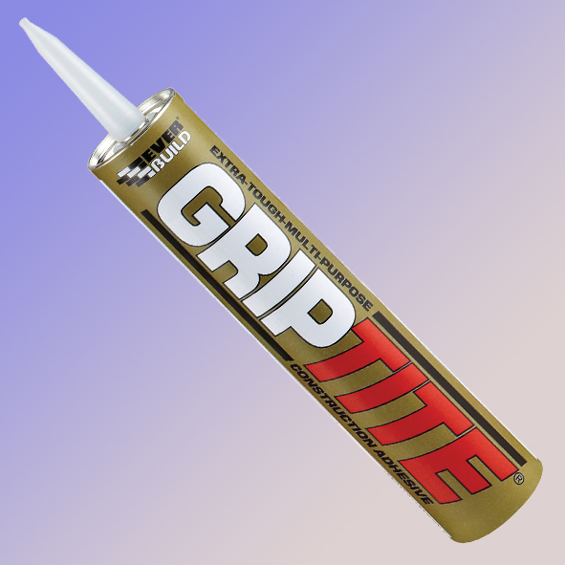

Colour | Product Code | Pack Size | Box Qty
Buff Green | GRIPTITEC3 | 310ML | 12
Buff Green | GRIPTITEC4 | 350ML | 12

Product Description
EveRBUILD GRIPTITE is a ready to use gap filling and panel adhesive based on a high bond strength synthetic rubber/resin mix in a solvent carrier. Adheres to most common surfaces inside and outside the home. Bonds to wood, plaster, plasterboard, carpet, carpet grippers, metal, glass, ceramics, brick, concrete, cork, uPVC and certain plastics.

Benefits
- Solvent based formula - quick drying / high early bond strength.
- Excellent adhesion/bond strength - adheres to most common surfaces.
- Good early grab properties - usable in both vertical and horizontal positions.
- High solids formulation - excellent gap filling properties without shrinkage.
- Suitable for use where both surfaces are non-porous.
- Excellent external weathering properties-Suitable for exterior use
- Excellent chemical resistance

Areas for Use
- Bonding dado rails, architrave’s and skirting
- Fixing parquet and cork flooring.
- Fixing wall cladding direct to internal wall surfaces or timber battens.
- Fixing battens directly onto walls without fastenings.
- Bonding carpet gripper systems to most floors without the need for nails or tacks.
- Bonding stair nosing to concrete or wooden stairs.
- Fixing polyester, wood, PVCu or metal thresholds.
- Fixing nameplates, plastic boxes, decorative frames, wall sockets and junction boxes to most surfaces.
- Securing aluminium or other skin panels to the framework or portable industrial buildings and
- caravans.

Limitations
- Do not use on damp surfaces: use EVERBUILD GUN A NAIL.
- Do not use as a mirror adhesive: use EVERBUILD MIRRORMATE
- Do not use on polystyrene/Styrofoam/expanded polyurethane - use EVERBUILD GUN A NAIL.
- Heavy materials (greater than 8kg per sq meter) must be supported for at least 8-24 hours depending on size of item.
- Solvents present may attack sensitive plastics. If in doubt, rest a small area first.

Surface Preparation
The surfaces to be glued must be clean, dry and free from dust, grease and other contaminants. New concrete or plaster should be allowed adequate time to dry and mature. If this is not possible, use EVERBUILD GUN A NAIL.
Porous or friable surface should first be primed with dilute contact adhesive and allowed to dry.

Application
1/ To bond flat panels direct to walls
Apply as a bead approx. 6mm in diameter around the periphery of the panel (50mm from the edge) and in horizontal lines at approximately 450mm centers. Immediately press the panel firmly to the wall surface to ensure adequate transfer of the adhesive and leave to set. A firm bond is achieved in 1 hour.N.B. If the panel is warped, apply the adhesive as described then press the panel firmly into the wall surface and pull away immediately. This will achieve a quicker adhesive transfer and allow quicker solvent evaporation. After 5 mins, the panel may then be bonded into position and a contact bond achieved.

2/ To bond Stair Nosings.
Apply adhesive to the stair nosing only. 2 or 3 beads may be necessary depending on the size of the nosing. Immediately press the nosing firmly into position to ensure adequate transfer of the adhesive. If a higher initial bond strength is required, press the nosing into position and then pull away to affect the adhesive transfer. Allow adhesive to dry apart for 5 minutes before pressing finally into position. Allow to dry for 24 hours before subjecting to traffic.

Bond Strength Build Up
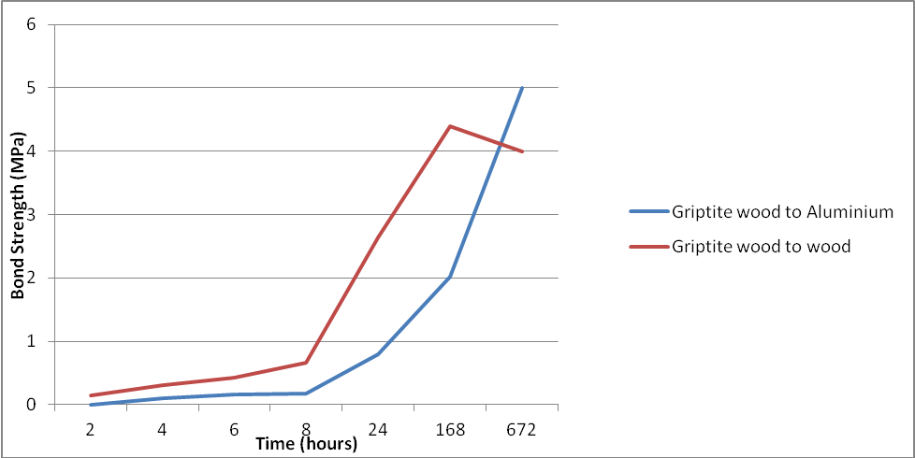

Specific Data
Form | Buff paste
Viscosity | 1800000 mPas
Coverage | Approx 10 linear meters
Solids Content | 72 +/- 1%
Ash Rate | 50 +/- 1%
VOC | 30 +/- 1%
Specific Gravity | 1.20 – 1.28
Flash Point | -10°C
Application Temperature | +5 to 40°C
Temperature Resistance | -20 to 50°C
Chemical Resistance | Strong bleech, 25% Caustic Soda, 10% Hydrochloric and Sulphuric Acids shown negligible effect on the product following full immersion over 1 week..

Health & Safety
Consult MSDS for full list of hazards.

Storage
Store in original unopened containers between 15 and 20ºC. Do not store above 30ºC. Store as flammable goods.

Shelf Life
12 months from date of manufacture in unopened containers.

The technical data contained herein is based on our present knowledge and experience and we cannot be held liable for any errors, inaccuracies, omissions or editorial failings that result from technological changes or research between the date of issue of this document and the date the product is acquired. Before using the product, the user should carry out any necessary tests in order to ensure that the product is suitable for the intended application. Moreover, all users should contact the seller or the manufacturer of the product for additional technical information concerning its use if they think that the information in their possession needs to be clarified in any way, whether for normal use or a specific application of our product. Our guarantee applies within the context of the statutory regulations and provisions in force, current professional standards and in accordance with the stipulations set out in our general sales conditions. The information detailed in the present technical data sheet is given by way of indication and is not exhaustive. The same applies to any information provided verbally by telephone to any prospective or existing customer.

