

CONSTRUCTION PRODUCTS REGULATION
DECLARATION OF PERFORMANCE
No: HYBSMP/1-CPR/ 2014

Substrate: Anodised aluminium and Mortar M1
Primer: No primer on Aluminium, Sikaflex Primer 3-N for Mortar
1. Identification Code | Everbuild TECNIC HYRIFLEX SMP  Codes: FPHYBSMP
2. Type, Batch and/or Serial Number | - For batch number - see packaging
3. Intended use | Sealant for non-structural use in joints in buildings and pedestrian walkways Part 1: Sealants for Façade elements
4. Manufacturer | Everbuild Building Products ltd, Site 41, Cross Green Industrial Estate, Knowsthorpe Way, Leeds, LS9 0SW
5. Authorised Representative | Not Applicable
6. Assessment and Verification of Constancy of Performance | System 3
7. Notified Body and Tasks | SKZ Notified Body No. 1213
8. European Technical Assessment | Not Applicable
9. Declared Performance TO EN15651-1 (2012)
Type | F EXT-INT-CC
Classification | F25HM
Reaction to Fire | Class E
Loss of Volume ISO10563 | ≤10%
Resistance to flow ISO7390 | ≤3 mm
Adhesion/cohesion properties at maintained extension after water immersion (23°C) ISO 10590 | NF
Adhesion/cohesion properties ISO 8340 modified (-30°C) | NF
Durability ISO 8340, ISO 9047 and ISO 10590 | Pass

Substrate: Anodised aluminium and Mortar M1
Primer: No primer on Aluminium, Sikaflex Primer 3-N for Mortar
1. Identification Code | Everbuild TECNIC HYRIFLEX SMP  Codes: FPHYBSMP
2. Type, Batch and/or Serial Number | - For batch number - see packaging
3. Intended use | Sealant for non-structural use in joints in buildings and pedestrian walkways Part 3: Sealants for Sanitary elements
4. Manufacturer | Everbuild Building Products ltd, Site 41, Cross Green Industrial Estate, Knowsthorpe Way, Leeds, LS9 0SW
5. Authorised Representative | Not Applicable
6. Assessment and Verification of Constancy of Performance | System 3
7. Notified Body and Tasks | SKZ Notified Body No. 1213
8. European Technical Assessment | Not Applicable
9. Declared Performance TO EN15651-4 (2012)
Type | PW EXT-INT-CC
Classification | PW25HM
Reaction to Fire | Class E
Loss of Volume ISO10563 | ≤10%
Resistance to flow ISO7390 | ≤3 mm
Adhesion/cohesion properties at maintained extension (23°C) ISO 8340 | NF
Tear Resistance ISO 8340 modified | NF
Adhesion / Cohesion properties at maintained extension 28 days water immersion (23°C) ISO 10590 modified | NF change of secant modulus: ≤50%
Adhesion / Cohesion properties at maintained extension 28 days salt water immersion (23°C) ) ISO 10590 modified | NF
Adhesion/cohesion properties at maintained extension (-30°C) ISO 8340 modified | NF
Durability ISO 8340, ISO 9047 and ISO 10590 | Pass

The performance of the product identified in points 1 and 2 is in conformity with the declared performance in point 9 . The declaration of performance is issued under the sole responsibility of the manufacturer identified in point 4.

Signed: I. G. Southerington – Head of Technical P.R. Thomas – Technical Manager
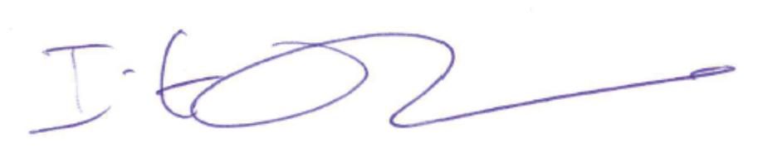
Dated: Leeds, 12/6/14

